“Unique Treasures”
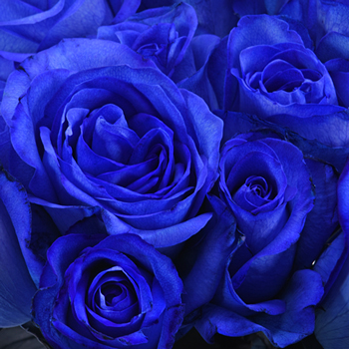

Blue roses represent mystery, the impossible, or the unattainable. Give a blue rose to someone and you are saying “you are extraordinarily wonderful and unique.” Blue roses are perfect for the woman who marches to the beat of her own drum. (obtained from google search)
As I pondered the prayer theme for the month of March, the idea of what the “Blue Rose” represents captured my attention. In addition to what google search reveals about this uniquely colored rose, it also represents the woman who marches to the beat of her own heart. She is tuned in, tapped in to her unique abilities and strengths while recognizing and being tolerant of her weaknesses. This leads me to the scripture in 2 Corinthians 4:7 “But we have this treasure in earthen vessels that the excellency of the power may be of God……”. As I use the words gifts and treasure interchangeably, awareness of the extraordinary power that we all possess is the focus. Locate the treasure within so that the light may shine brightly throughout.

The blueprint or treasure map are the visions and dreams that are inspired from within. If you have a desire to be a top producing Agent, amazing teacher, great parent or one to empower others to live their best life, believe that whatever desire or vision that shows up, it is attainable. Some of us may need to dig and search a little deeper than others for our treasure, partly because we’ve lost touch with our inner guiding voices. A voice that requires that we spend uninterrupted quiet time to reconnect and listen. This step is imperative to connection, understanding and growth. It will lead us to a revelation of which books to read, what conferences to attend, which people to hang out with and which tribe to join. These are only a few tools that are vital in our quest to find our inner treasures.
The search will be different for each of us based on our uniqueness as individuals. However, there is a collective connection as well. Some searches may consist of getting quiet, meditating and intently focusing to discover the true purpose of the treasure. Meanwhile, others seeking their treasures may enjoy the excitement and energy of the dig. Others may have already discovered the inner treasures and are exploring the contents and using the gifts to be of service to others. Questionably, others may be standing gazing at the treasure wondering if they’re worthy of such gifts. Wondering if they can handle the power, responsibilities, vulnerabilities and transparency that come with allowing the treasure to be seen.

The treasure is like a seed even as we are seeds planted here in society. Most of what we need to develop into our uniquely designed masterpieces are tucked away inside. Every seed needs an environment in which to grow. This growth is influenced by outside sources such as soil, water and the sun. This shows up in the company we keep. Hardened soil lacks protection and nutrients. Too much water can rot or drown the seed. Too much sun can scorch when the fragile sprouts begin to break through to the surface. Whatever it takes to locate your inner treasure and cultivate your seed do it! And if you’ve already found it know that you’re worthy of it and let the light shine upon it! More importantly, if you’ve matured, share it! Under developed fruit is bitter and not pleasing to the taste buds. However, fully developed fruit is delicious and a celebration to the palate. Be aware of the stage you’re in and by all means……. Enjoy the journey, discovery and exposure of your treasure/gifts. Then graciously share your treasure with others……. become the water and sun for them, just as those that were the water and sun for you. As such, you are actively demonstrating the power required to bring forth “…. this treasure in earthen vessels that the excellency of the power may be of God….

