Harmonious Growth
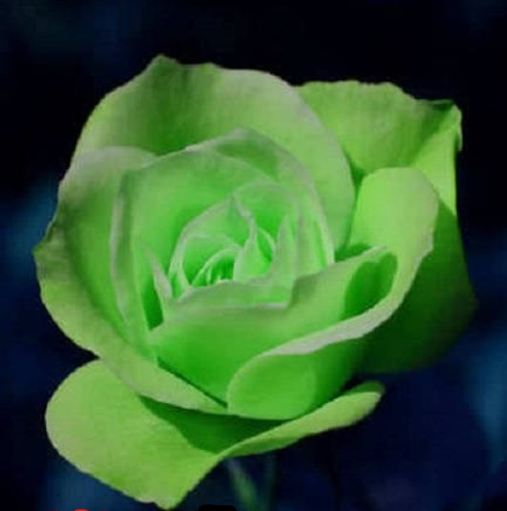

Green roses: Green is the color of harmony. It is the color of life, abundant growth and constant renewal of life and energy. The green rose signifies the constant rejuvenation of spirit.
The month of April reflect a season of growth and a time when trees and flowers begin to blossom. Our theme for this month is experiencing and creating harmonious growth. Harmony means that everything is co-existing in a space of cooperation. Getting to this place requires that we are absolutely clear on who we are and what our roles are. Once this is accomplished, we move into a space of excellence rather that perfection, to manifest our purpose. What is your role in your family, your business, the community? Having a vision and action steps of how that looks, will ultimately lead to the level of impact and influence you will have.
Growth is not synonymous to pain as some may believe. We’ve heard the sayings “No Pain no gain” or “No progress without struggle”. I’d like to offer a different perspective. When we look at the growth of a child from infancy to adult, there is no pain associated with the physical growth of a healthy body. Oftentimes, a child doesn’t realize how much they’ve grown until they stand and excitedly watch as their parents mark a growth line on the wall. Everything in the body including the inner organs are growing to maturity by design. The harmonious way in which the members of the body flow together creates beauty in motion.

Ephesians 4:16
GOD'S WORD® Translation
He makes the whole body fit together and unites it through the support of every joint. As each and every part does its job, making the body grow so that it builds itself up in love.
New Living Translation
He makes the whole body fit together perfectly. As each part does its own special work, it helps the other parts grow, so that the whole body is healthy and growing and full of love.
What amazing results will we experience if we applied these scriptures to our everyday lives? What if we shift our focus to individually mastering our role and come together in unity rather than competition to perpetuate growth. Just imagine your hands competing with your feet when you want to run a marathon. Or your brain competing with your heart, seems a bit ridiculous! Each member of the body was created for a specific purpose. To fulfill this purpose, it is fed the proper nutrients and have a level of activity to keep it operating the way it was intended. Pain and struggle can be a result of neglect or malnourishment or another form of interruption of what flows naturally. In this instance, identifying the source of disruption and taking the proper steps to restore is key.
When we embrace this idea and model of harmonious growth, replicate it within our families, businesses and community we will create an atmosphere of vitality and limitless positive results. Specifically focusing on the Real Estate Industry and restoring our communities, what steps are needed? Identify your individual place in the body. Ensure that you are operating in your highest and best self in this role. Unite with others that are complimentary to the body having all its parts in place. For example, to revitalize a community, the body may consist of a Realtist, Architect, Contractor, Lender, Appraiser, Attorney etc. Each member has a role to play and they find a way to unify their roles for the greater good. They create harmonious flow and synergy to revitalize the community while serving in their perspective roles. Growth and stabilization of the community will be a byproduct of servicing the housing industry in the spirit of harmony and unity.
I invite you this month to be “Agents of change”. How can you create change in your home, community and ultimately the nation? I invite you to be a conduit of harmonious influence. For the next 30 days jot down harmony in action. Also, be mindful of how your blossoming can influence change to create harmony and inspire growth. Cooperation is a choice that leads to harmony. Which choice will you make?

If there is beauty in character, there will be harmony in the home. If there is harmony in the home, there will be order in the nation. If there is order in the nation, there will be peace in the world. (Chinese Proverb)

